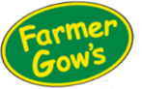
Mobile Farm Booking Form – 2023
* please delete as applicable
Contact name
School/Group/Event
Address
Postcode
Telephone number
Mobile number
Email
Date of Visit
Preferred start time
Educational or Event | Educational * Event
Approx. no. of children?
How long/many hours would you like us to visit?
Medium or Large visit? | Medium * Large
Are there any special conditions we need to know about? Religious matters, allergies, disabilities etc
Please email your Booking Form to ~ education@farmergows.co.uk
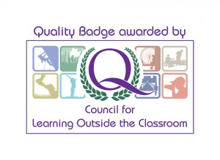
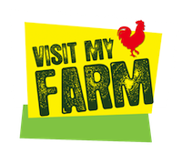
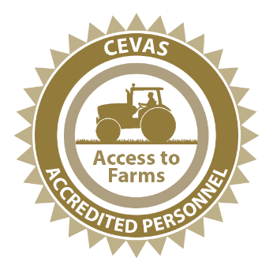
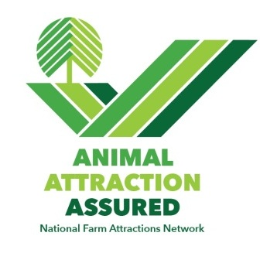
We will reply by email with a programme, quotation and risk assessment

How to book a Mobile Farm
- Complete our no obligation Booking Form and send it to us at
education@farmergows.co.uk
- We will then contact you by telephone to chat through your booking, discuss a suitable programme and check access for our farm truck/trailer.
- We will follow up the call by email with a programme and a quotation for the visit.
- The Mobile Farm is confirmed once you reply to our email.
Please note – the maximum distance we can travel is 1 hour from the farm. Any further is too stressful for our animals.

Frequently Asked Questions
- How far do we go?
A About 1 hour from the farm, it depends a bit how far this is but google maps is a good guide.
- How long can we visit?
A 30-minutes to 6 hours. Sarah will chat through a programme with you to ensure your children and adults get great farm animal contact.
- How much will it cost?
A We have quite a lot of work to do to prepare the Mobile Farm for a visit. We have to travel to and from your site and clean all our equipment on our return to the farm.
- Once we have your Booking Form and you have chatted with Sarah, we will provide a quotation by email. You are welcome to accept or decline our quotation.
A Please see minimum costs for Medium and Large visits. These guides are pretty accurate if you are local. They will increase with travel time and time spent on your premises.
- Invoice
A Schools – You will be invoiced at the end of the trip. The invoice will include direct payment details.
Private functions – you will be invoiced prior to the event. Payment in full 5 days before the mobile farm visit.
- Farmer Gow’s Education Ltd is not VAT registered.
- Where to send your Booking Form - education@farmergows.co.uk

