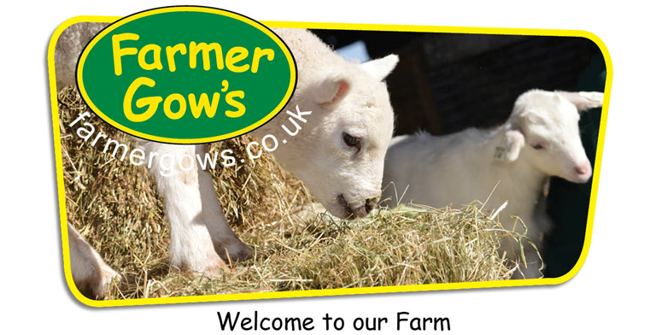
2021 Birthday Party packages ~

- All-in party £12.95/child (3-16 yrs) £8.95/child (2 yrs) £8.75/adult

 | 1+ hour ‘hands on’ Meet the Animals farm fun |  |  | Party name labels and farm animal stickers
 | Treasure Hunt on the giant Bale Climb |  |  | Private party area
 | 30-40 minutes for birthday lunch or tea |  |  | Party planner
 | ‘free play’ in the adventure play areas |  |  | Lunch / Tea boxes
 | Free party invitations |  |  | Cleaning service

- All-in-Plus party £13.95/child (3-16 yrs) £9.95/child (2 yrs) £8.75/adult

 | 1+ hour ‘hands on’ Meet the Animals farm fun |  |  | Party name labels and farm animal stickers
 | Treasure Hunt on the giant Bale Climb |  |  | Private party area
 | 30-40 minutes for birthday lunch or tea |  |  | Party planner
 | ‘free play’ in the adventure play areas |  |  | Party food with sandwiches or hot dogs
 | Free party invitations |  |  | Cleaning service

- Self Catering party £11.60/child (3-16 yrs) £6.95/child (2 yrs) £8.75/adult

 | 1+ hour ‘hands on’ Meet the Animals farm fun |  |  | Party name labels and farm animal stickers
 | Treasure Hunt on the giant Bale Climb |  |  | Private party area
 | 30-40 minutes for birthday lunch or tea |  |  | Party planner
 | ‘free play’ in the adventure play areas
 | Free party invitations

Optional extras
- Party bags
  - £3.75 – Farm themed party bag with 3 toys
  - £4.85 – Fun at the Farm, the Oxford Reading Tree book about Kipper’s adventures at Farmer Gow’s
- Tray of sandwiches for adults - £4.25/adult. Hot dogs and burgers also available.

2021 Birthday Party - Booking Form
Contact details |  | Please complete all below
Birthday child’s name
Birthday age
Parent names
Parent address

Postcode
Contact telephone number
Email address
Date of party
Party timings
AM | 10.30 am – 1 pm | Yes/No*
Midday | 12 noon – 3 pm | Yes/No*
PM | 1.30 - 4 pm | Yes/No*
Party invitations – how many would you like?
Invitations are free of charge.
They include a map to the farm and will be posted to you. We will also email an electronic invite.
Party Package
All-in  Includes lunch/tea boxes | £12.95 / child  £8.95 / 2 yrs  £8.75 / adult | Yes/No*
All-in-Plus  Includes party food with hot dogs or sandwiches | £13.95 / child  £9.95 / 2 yrs  £8.75 / adult | Yes/No*  hot dogs or sandwiches
Self Catering  Bring your own food | £11.60 / child  £6.95 / 2 yrs  £8.75 / adult | Yes/No*
* Vegetarian, gluten, allergies – please advise on your Guest List *
Adults – the normal entry price for adults is £10.60. We offer a discounted rate for £8.75 for Birthday Parties.
Optional extras
Food for adults
Tray of sandwiches with fruit, salad and crisps | £4.25 / adult | Yes/No*
Party bags
Farm | £3.75 each | Yes/No*
Fun at the Farm | £4.85 each | Yes/No*
Please ask if you have any further requests/requirements, we are always happy to assist.

2021 Birthday Parties

Booking

Online https://www.farmergows.co.uk/c/Childrens_Birthday_Parties/eca620c9db4543bd8fad6b61b29a80c1/

Farm Office Open daily, 10am – 5pm

Telephone 01793 780 555

Email enquiries@farmergows.co.uk

Please send us a completed Booking Form.

We will then contact you for a £30 credit/debit card non-refundable deposit

Post Send your completed Booking Form to

Farmer Gow’s, Fernham Road, Longcot, Faringdon, SN7 7PR

Please include a £30 non-refundable deposit

Confirmation Bookings will be confirmed by email

Printed invitations - will be sent by post (free of charge)

Electronic invites - will be sent by email

Guest list Please send us your Guest List (adults and children on your tab), 3 days before your party

We will use the list to welcome your guests and prepare your party area
Birthday Party Terms & Conditions

Extra Guests Extra guests, who are not on your guest list, may use your party discount to pay their own entrance charge at reception.

Maximum / Minimum There is no maximum nor minimum number of party children. You are welcome to invite as many guests as you wish. The farm will use your Guest List to provide plenty of room in your reserved party area and in the Meet the Animals activity areas.

Child Supervision We offer Birthday Party hosts discounted adult entry to support the supervision of child party guests.

Supervision Rates We recommend supervision rates as follows ~
  - Under 3’s 1 adult : 2 children
  - Under 5’s 1 adult : 4 children
  - Under 8’s 1 adult : 6 children
  - Over 8’s 1 adult : 8 children
Party hosts are responsible for the conduct and behaviour of party guests.
Deposit A £30 deposit is required at time of booking and is non-refundable.
Party Area Your party area is available throughout the party. Non-valuables may be left in this area, at owners’ risk.
Self Catering Sorry, we cannot take responsibility for any items, including food/drinks. You are responsible for leaving your party area clean and tidy, including removing any refuse.

Birthday Party Checklist
Check | Task | Notes
Book party / Questions
 | Farm Office daily 10am – 5pm
 | Telephone 01793 780 555
 | Email enquiries@farmergows.co.uk
 | Online https://shop.farmergows.co.uk/c/Birthday_Parties/eca620c9db4543bd8fad6b61b29a80c1/
Invites
 | Download electronic invite tenplate with directions to the farm
 | Printed invites arrive in the post
 | Write and send out invitations
Guest List
 | Wednesday before the party, send to enquiries@farmergows.co.uk
Birthday Cake
 | Buy, order or make
Candles, Matches
 | Buy, order or hunt through a drawer to find
Party Bags
 | Order from Farmer Gow’s, or
 | Buy
Self Catering Parties
 | Plates
 | Napkins
 | Bowls
 | Cups
 | Jugs
 | Cutlery
 | Food
 | Dessert
 | Drinks
 | Rubbish sack, please take your rubbish home with you
Other

Birthday Party Guest List

Please return you Guest List, by the previous Wednesday for Saturday or Sunday parties.

We will use the list to welcome your guests and prepare your party area/refreshment orders.
Email enquiries@farmergows.co.uk
Posted Farmer Gow’s, Fernham Road, Longcot, Faringdon, SN7 7PR
Party child’s name |  | Date of Party

- First names only
- You will be invoiced at the end of the party for the adults and children included on this list
- Any additional adults (family/friends of guests) who are not on this list may pay their own entrance to the farm at reception, at the discounted party rate of £8.50/adult
- Please indicate with an ‘M’ any children or adults who hold Membership passes

Children
Ser | Name | Girl (G)  Boy (B) | 3-16 yrs  √ | 2 yrs  √ | - yrs  √ | M  √

Please advise any child allergies –

Adults

Ser | Name | Membership Pass holder √

Please advise any adult allergies –

We look forward to welcoming you and your friends to the farm.

