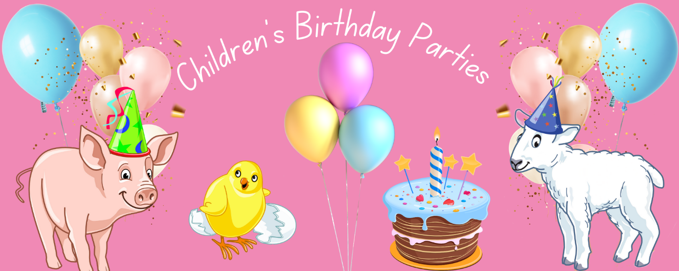**Birthday Parties - 2025 packages**

1. **All-in** Prices Children: 0-1 yrs – entry FOC 2 yrs - £11.30 3-16 yrs - £15.70

Adult: £10.25 Treasure Hunt £3 Food box £4.85

|  |  |  |  |  |
| --- | --- | --- | --- | --- |
|  | 1+ hour ‘hands on’ Meet the Animals farm fun |  |  | Party name labels and farm animal stickers |
|  | Treasure Hunt on the giant Bale Climb |  |  | Private party area |
|  | 30-40 minutes for birthday lunch or tea |  |  | Party planner |
|  | ‘free play’ in the adventure play areas |  |  | Lunch / Tea boxes |
|  | Free party invitations |  |  | Cleaning service |

1. **All-in-Plus** Prices Children: 0-1 yrs – entry FOC 2 yrs - £12.30 3-16 yrs - £16.70

Adult: £10.25 Treasure Hunt £3 Party food £5.90

|  |  |  |  |  |
| --- | --- | --- | --- | --- |
|  | 1+ hour ‘hands on’ Meet the Animals farm fun |  |  | Party name labels and farm animal stickers |
|  | Treasure Hunt on the giant Bale Climb |  |  | Private party area |
|  | 30-40 minutes for birthday lunch or tea |  |  | Party planner |
|  | ‘free play’ in the adventure play areas |  |  | Platters of party food with plates sandwiches |
|  | Free party invitations |  |  | Cleaning service |

1. **Self-catering** Prices Children: 0-1 yrs – entry FOC 2 yrs - £7.20 3-16 yrs - £11.60

Adult: £10.25 Treasure Hunt £3

|  |  |  |  |  |
| --- | --- | --- | --- | --- |
|  | 1+ hour ‘hands on’ Meet the Animals farm fun |  |  | Party name labels and farm animal stickers |
|  | Treasure Hunt on the giant Bale Climb |  |  | Private party area |
|  | 30-40 minutes for birthday lunch or tea |  |  | Party planner |
|  | ‘free play’ in the adventure play areas |  |  |  |
|  | Free party invitations |  |  |  |

**Optional extras**

* Party bags
  + £4.75 – Farm themed party bag with 3 toys
  + £6.50 – Fun at the Farm, the Oxford Reading Tree book about Kipper’s adventures at Farmer Gow’s
* Tray of sandwiches for adults - £4.95/adu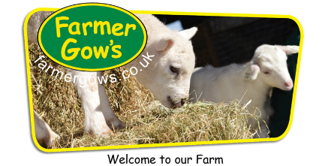lt. Hot dogs and burgers also available.

**Birthday Parties - 2025**

**Booking & Further Information**

## Online <https://www.farmergows.co.uk/c/Childrens_Birthday_Parties/eca620c9db4543bd8fad6b61b29a80c1/>

## Farm Office Tel 01793 780 555 or 07714 455 400

## Email [parties@farmergows.co.uk](mailto:parties@farmergows.co.uk)

## **Confirmation** Bookings will be confirmed by email

## Printed invitations - will be sent by post (free of charge)

## Electronic invites - will be sent by email

## **Guest list** Please send us your **Guest List** (adults and children on your tab), 3 days before your party

## We will use the list to welcome your guests and prepare your party area

Birthday Party Terms & Conditions

## Extra Guests Extra guests, who are not on your guest list, may use your party discount to pay their own entrance charge at reception.

## Maximum / Minimum There is no maximum nor minimum number of party children. You are welcome to invite as many guests as you wish. The farm will use your **Guest List** to provide plenty of room in your reserved party area and in the Meet the Animals activity areas.

## Child Supervision We offer Birthday Party hosts discounted adult entry to support the supervision of child party guests.

## Supervision Rates We recommend supervision rates as follows ~

* + Under 3’s 1 adult : 2 children
  + Under 5’s 1 adult : 4 children
  + Under 8’s 1 adult : 6 children
  + Over 8’s 1 adult : 8 children

Party hosts are responsible for the conduct and behaviour of party guests.

Deposit A £30 deposit is required at time of booking and is non-refundable.

Party Area Your party area is available throughout the party. Non-valuables may be left in this area, at owners’ risk.

Self Catering Sorry, we cannot take responsibility for any items, including food/drinks. You are responsible for leaving your party area clean and tidy, including removing any refuse.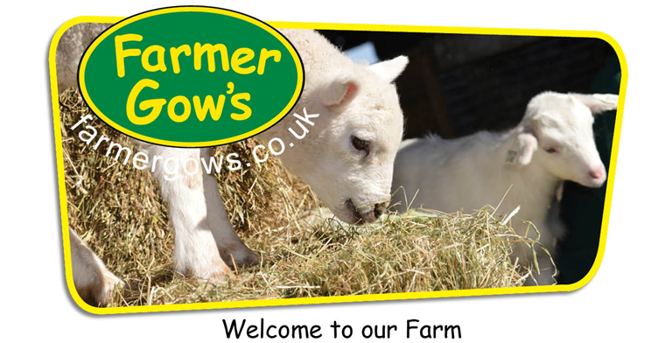

**Birthday Party Checklist**

|  |  |  |
| --- | --- | --- |
| Check | Task | Notes |
| **Book party / Questions** | | |
|  | Farm Office 01793 780 555 |  |
|  | Mobile 07714 455 400 |  |
|  | Email [parties@farmergows.co.uk](mailto:parties@farmergows.co.uk) |  |
|  | Online <https://shop.farmergows.co.uk/c/Birthday_Parties/eca620c9db4543bd8fad6b61b29a80c1/> |  |
| **Invites** | | |
|  | Download electronic invite tenplate with directions to the farm |  |
|  | Printed invites arrive in the post |  |
|  | Write and send out invitations |  |
| **Guest List** | | |
|  | Wednesday before the party, send to parties@farmergows.co.uk |  |
| **Birthday Cake** | | |
|  | Buy, order or make |  |
| **Candles, Matches** | | |
|  | Buy, order or hunt through a drawer to find |  |
| **Party Bags** | | |
|  | Order from Farmer Gow’s, or |  |
|  | Buy |  |
| **Self Catering Parties** | | |
|  | Plates |  |
|  | Napkins |  |
|  | Bowls |  |
|  | Cups |  |
|  | Jugs |  |
|  | Cutlery |  |
|  | Food |  |
|  | Dessert |  |
|  | Drinks |  |
|  | Rubbish sack, please take your rubbish home with you |  |
|  |  |  |
| **Other** | | |
|  |  |  |
|  |  |  |



**Birthday Party Guest List - Children**

## Please return you Guest List, by the previous Wednesday for Saturday or Sunday parties.

## We will use the list to welcome your guests and prepare your party area/refreshment orders.

Email [enquiries@farmergows.co.uk](mailto:enquiries@farmergows.co.uk)

Posted Farmer Gow’s, Fernham Road, Longcot, Faringdon, SN7 7PR

|  |  |  |  |
| --- | --- | --- | --- |
| Party child’s name |  | Date of Party |  |

* First names only
* You will be invoiced at the end of the party for the adults and children included on this list
* Any additional adults (family/friends of guests) who are not on this list may pay their own entrance to the farm at reception, at the discounted party rate of £10.25/adult (general, Day Ticket entry is £13.15)

Children

|  |  |  |  |  |  |
| --- | --- | --- | --- | --- | --- |
| Ser | Name | Girl (G)  Boy (B) | 3-16 yrs  √ | * 1. yrs   √ | Babies  √ |
|  |  |  |  |  |  |
|  |  |  |  |  |  |
|  |  |  |  |  |  |
|  |  |  |  |  |  |
|  |  |  |  |  |  |
|  |  |  |  |  |  |
|  |  |  |  |  |  |
|  |  |  |  |  |  |
|  |  |  |  |  |  |
|  |  |  |  |  |  |
|  |  |  |  |  |  |
|  |  |  |  |  |  |
|  |  |  |  |  |  |
|  |  |  |  |  |  |
|  |  |  |  |  |  |
|  |  |  |  |  |  |
|  |  |  |  |  |  |
|  |  |  |  |  |  |
|  |  |  |  |  |  |
|  |  |  |  |  |  |

**Please advise any child allergies –**

**Birthday Party Guest List - Adults**

## Please return you Guest List, by the previous Wednesday for Saturday or Sunday parties.

## We will use the list to welcome your guests and prepare your party area/refreshment orders.

Email [enquiries@farmergows.co.uk](mailto:enquiries@farmergows.co.uk)

Posted Farmer Gow’s, Fernham Road, Longcot, Faringdon, SN7 7PR

|  |  |  |  |
| --- | --- | --- | --- |
| Party child’s name |  | Date of Party |  |

* First names only
* You will be invoiced at the end of the party for the adults and children included on this list
* Any additional adults (family/friends of guests) who are not on this list may pay their own entrance to the farm at reception, at the discounted party rate of £10.25/adult (general, Day Ticket entry is £13.15)

Adults

|  |  |
| --- | --- |
| Ser | Name |
|  |  |
|  |  |
|  |  |
|  |  |
|  |  |
|  |  |
|  |  |
|  |  |
|  |  |
|  |  |
|  |  |
|  |  |
|  |  |
|  |  |
|  |  |
|  |  |
|  |  |
|  |  |
|  |  |
|  |  |

**Please advise any adult allergies –**

We look forward to welcoming you and your friends to the farm.