#### 2026 Booking Form - Mobile Farm

*\* please delete as applicable*

|  |  |
| --- | --- |
| Contact name |  |
| School / Group / Event |  |
| Address |  |
| Postcode |  |
| Telephone number |  |
| Mobile number |  |
| Email |  |
| Date of Visit |  |
| Preferred start time |  |
| Educational or Event | Educational * Event |
| Approx. no. of children? |  |
| How long/many hours would you like us to visit? |  |
| Medium or Large visit? | Medium * Large |
| Are there any special conditions we need to know about? Religious matters, allergies, disabilities etc | |
|  | |

Please email your Booking Form to ~ [Education@farmergows.co.uk](mailto:education@farmergows.co.uk?subject=Countryside%20Education%20-%20booking%20a%20Farmer%20Gow's%20Mobile%20Farm)**.** We will reply by email with a programme, quotation and risk assessment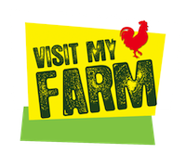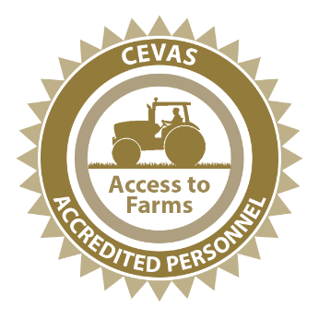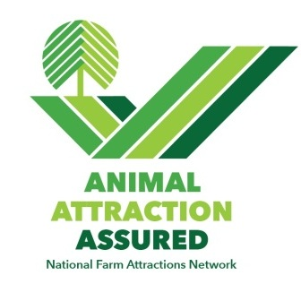.

### How to book a Mobile Farm

* Complete our *no obligation* Booking Form and send it to us at

[Education@farmergows.co.uk](mailto:education@farmergows.co.uk?subject=Countryside%20Education%20-%20booking%20a%20Farmer%20Gow's%20Mobile%20Farm)

* We will then contact you by telephone to chat through your booking, discuss a suitable programme and check access for our farm truck/trailer.
* We will follow up the call by email with a programme and a quotation for the visit.
* The Mobile Farm is confirmed once you reply to our email.

### Frequently Asked Questions

* How far do we go?

A The **maximum** distance we can travel is 1-hour drive time from the farm. We use Google Maps to check the distance from the farm to your location. Any further is too stressful for our young farm animals.

We must return to the farm by 5pm. Any later is too long a day for our young animals

We operate under 4 different Government departments who each have slightly different rules for different reasons - mostly ensuring health and wellbeing of livestock and you. The rules are complex and different for each farm animal species. The combined effect of these different rules is that we can only undertake 1 Mobile Farm visit per week. We recommend booking early, to avoid disappointment.

* How long can we visit?

A 30-minutes to 6 hours. Anne will chat through a programme with you to ensure your children and adults get great farm animal contact.

* How much will it cost?

A We have a lot of work to do to prepare the Mobile Farm for a visit. We have to travel to and from your site and clean all our equipment on our return to the farm.

* Once we have your Booking Form and you have chatted with Anne, we will provide you with a programme and quotation by email. You are welcome to accept or decline our quotation.

A Please see minimum costs for [Medium](https://www.farmergows.co.uk/mobilefarm/#mediumcost) and [Large](https://www.farmergows.co.uk/mobilefarm/#largecost) visits. These guides are pretty accurate if you are local. They will increase with travel time and time spent on your premises.

* Invoice

A Schools – You will be invoiced at the end of the trip. The invoice will include direct payment details.

Private functions – you will be invoiced prior to the event. Payment in full 5 days before the mobile farm visit.

* Farmer Gow’s Education Ltd is not VAT registered.
* Where to send your Booking Form - [Education@farmergows.co.uk](mailto:education@farmergows.co.uk?subject=Countryside%20Education%20-%20booking%20a%20Farmer%20Gow's%20Mobile%20Farm)